Escape from Sector IX

# Design Document

# Description

A fast paced stealth puzzle game where a failed science experiment must escape from the clutches of a murderous corporation bent on killing all evidence of the experiment. The player has to navigate a deadly security system that has been installed into the facility. Each level gets progressively harder as the player continues to move towards the surface.

The game will contain elements similar to:

* Stealth Bastard Deluxe
* Monaco
* Super Meat Boy

# Mechanics

The game will be split into a multitude of levels. Each level will contain one entrance and a clearly defined exit. All obstacles should be clearly defined and visible to the player. The challenge will be to traverse the level without running into any of the deadly traps or being killed by any of the enemies.

Progression and reward will be built into each level. They will get continuously more difficult. Lowering to difficulty to introduce new mechanics and then raising it again as they are then combined and used to build complex traps. The player should feel challenged to the point where finally passing a level will make them feel empowered.

The player character will only have the ability to move around the level. There will be no power ups or character modification through the game. The game will focus on progressing through the levels of difficulty without making the player any more equipped.

The entire movement mechanic will be locked to a grid, but movement will be fluid and fast paced allowing for it to appear unrestricted.

|  |  |  |
| --- | --- | --- |
|  |  |  |
|  |  |  |
|  |  |  |

|  |  |  |
| --- | --- | --- |
|  |  |  |
|  |  |  |
|  |  |  |

The player will have to navigate traps created from the following

* Lasers
  + Will be static or moving depending on the puzzle.
  + Will kill instantly upon contact with the player or an enemy
* Turret
  + Are equipped with lasers and will fire on sight of the player
  + Have perfect accuracy
  + Do not move, they act as static posts only
* Sentry Robots
  + Are equipped with lasers that will fire on sight of the player
  + Have perfect accuracy
  + Follow a fixed path through the environment

The environment contains features that can be used to navigate harder traps

* Moving walls
  + Will hide the player from guards
  + Collision box when in contact with the player
  + Cannot be stopped or influenced
  + Follow a generic and predictable path
  + Will stop laser beams if paths are crossed
* Movable crates
  + Will hide the player from guards
  + Can be pushed by the player
  + Safe area for player
  + Will stop laser beams if they cross paths

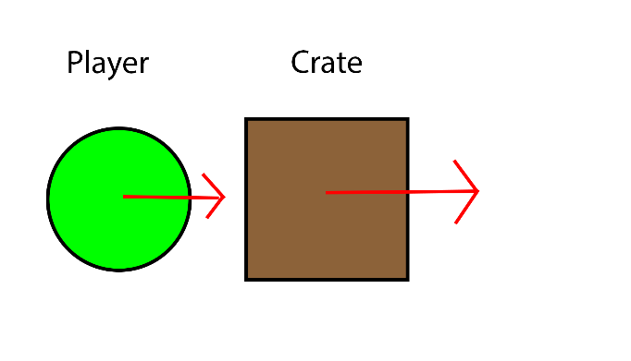

This will be a rage inducing game where death is around every corner. There will be no interrupt if the player dies. Some crucial puzzle or survival elements may be reset. The player will respawn from the start of the level without any prompt. There will be no penalty for dying.

All enemies will have a full 360 degree line of sight. This will make them a more considerable threat to the player. Many of the enemies will be static and used to block off a section of the possible paths from the player. The enemies that can move will do so by following a fixed path around a portion of the level.

Detection by enemies will be based on line of sight. After the enemy has obtained a direct line of sight with the player. After line of sight is made, a very brief warning tone will be played. This is to alert the player of their imminent death, and possible safety if they are close to a safe area.

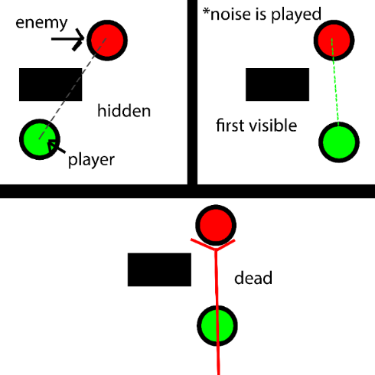

# Pillars

* Fast paced and fluid gameplay
* Thoughtful puzzles
* Constant danger of dying

# Style

The color scheme will consist of vibrant colors contrasting against a dark overall theme for the facility. The following colors will be the main color palette for the game.



The main screens and menus will have a clean blocky look to them. All elements divided into sections and separated by a common background.

Title Screen: Pause Menu Overlay:

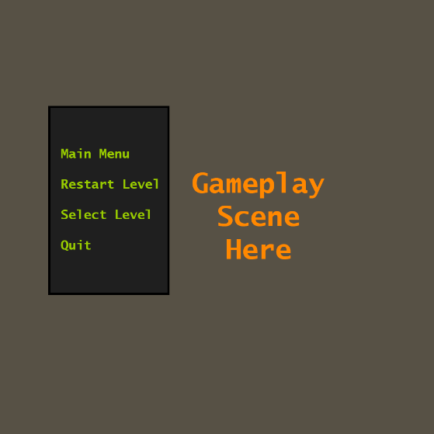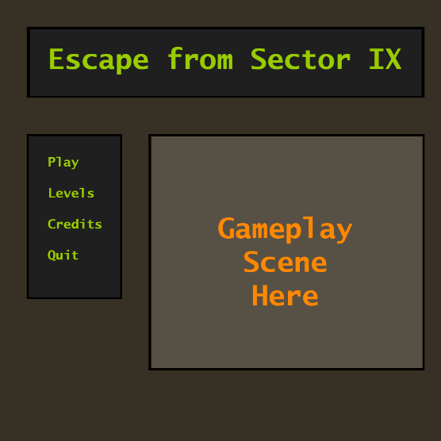

# Screen Mockup

